Work - 01
CLASS 09 - SCIENCE

 | Section A
1 | A key of a mechanical piano struck gently and then struck again but much harder this time. In the second case  a) Sound will be louder but pitch will not be differ  b) Both loudness and pitch will remain unaffected  c) Sound will be louder and pitch will also be higher  d) Sound will be louder but pitch will be lower | [1]
2 | A boat is rocked by waves such that a crest and a trough reach at an interval of 0.1 seconds with a speed of 50 m/s. The distance between two consecutive crests is  a) 5 m  b) 20 m  c) 10 m  d) 15 m | [1]
3 | In an auditorium or big hall the walls are provided with sound - absorbant materials, why?  a) To make the hall look better.  b) So, that the sound from the stage may be heard properly.  c) So, that echo effect may be minimized.  d) So, that the sound may appear to be pleasing | [1]
4 | A pulse  a) is a short duration disturbance  b) does not repeat  c) all of these  d) can travel | [1]
5 | Which of the following is not the character of mechanical waves?  a) Can be both transverse or longitudinal  b) Propagation depends on the elasticity of medium  c) Requires a material medium  d) Speed is comparatively higher | [1]
6 | For reflection of sound wave, we need:  a) A large size, the opaque reflecting surface  b) A glass plate  c) A polished mirror  d) A concave surface painted blue | [1]
7 | Two sounds of same pitch and loudness differ in their:  a) note  b) frequency  c) tone  d) quality | [1]
8 | Wave motion transfers  a) mass  b) velocity  c) energy  d) momentum | [1]
9 | The audible range of the human ear is:  a) 2Hz - 2000 Hz  b) 2Hz - 20 kHz  c) 20 Hz - 20 MHz  d) 20 Hz - 20,000 Hz | [1]
10 | Sonic booms are caused by the combination of  a) pressure variation only  b) infrasonic speed and pressure variation  c) supersonic speed and pressure variation  d) ultrasonic sound and pressure variation | [1]
11 | Speed of sound in air and water are given as v$​_{a}$ and v $​_{w}$ respectively. Then  a) v$​_{w}$ > v $​_{a}$  b) v$​_{a}$ = v $​_{w}$  c) v$​_{a}$ > v $​_{w}$  d) v$​_{a}$ = 2v $​_{w}$ | [1]
12 | When we change feeble sound to loud sound we increase its  a) Velocity  b) Amplitude  c) Wavelength  d) Frequency | [1]
13 | Sometimes sound produced by bats, dolphins are  a) all of these  b) ultrasonic  c) ultraviolet  d) infrasonic | [1]
14 | Infrasonic f$​_{i}$ , Audible f $​_{a}$ and ultrasonic f $​_{u}$ sounds are related as  a) f$​_{a}$ < f $​_{u}$ < f $​_{i}$  b) f$​_{i}$ < f $​_{a}$ < f $​_{u}$  c) f$​_{i}$ > f $​_{a}$ > f $​_{u}$  d) f$​_{a}$ < f $​_{i}$ < f $​_{u}$ | [1]
15 | Echo is not heard in a room of 10m$×$ 10m $×$ 10m dimension due to (speed of sound in air = 300 m/s).  a) reflection  b) humidity  c) absorption  d) persistence | [1]
16 | Match the column I with column II and mark the correct option from the codes given here. 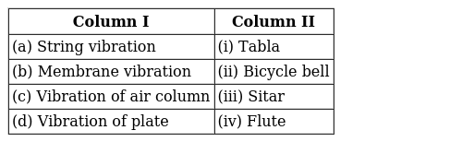  a) (a) - (i), (b) - (iv), (c) - (ii), (d) - (iii)  b) (a) - (ii), (b) - (iii), (c) - (i), (d) - (iv)  c) (a) - (iv), (b) - (ii), (c) - (iii), (d) - (i)  d) (a) - (iii), (b) - (i), (c) - (iv), (d) - (ii) | [1]
17 | In which of the following medium will the sound wave travel faster  a) Vacuum  b) Air  c) Steel  d) Water | [1]
18 | The types of wave produced by sound in air:  a) Electro magnetic wave  b) Transverse wave  c) Longitudinal wave  d) Radio waves | [1]
19 | Speed of light or electromagnetic wave is higher than that of the speed of sound in air by  a) 10$​^{7}$ times  b) 10$​^{6}$ times  c) 10$​^{8}$ times  d) 10$​^{5}$ times | [1]
20 | In SONAR, we use  a) Infrasonic waves  b) Audible sound waves  c) Radio waves  d) Ultrasonic waves | [1]
21 | A student while verifying the laws of reflection of sound measured the angle between the incident sound wave and reflected sound wave as 110$​^{o}$ . The angle of reflection is:  a) 220$​^{o}$  b) 110$​^{o}$  c) 55$​^{o}$  d) 27$​^{o}$ | [1]
22 | Infrasound can be heard by  a) Human beings  b) rats  c) Rhinoceros  d) Bat | [1]
23 | Sound waves cannot propagate in  a) metals  b) air  c) water  d) vacuum | [1]
24 | In a wave motion in string, every particle:  a) displaces from one end to the other end  b) does not displace at all  c) oscillates  d) does not oscillate | [1]
25 | The following figure shows the displacement time graph for a sound wave produced by an instrument. 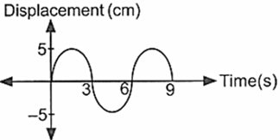  Which graph can be obtained when another musical instrument produces a note of the same pitch but of a different quality?  a) 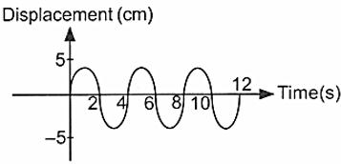  b) 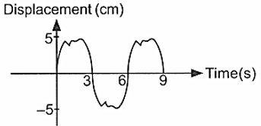  c) 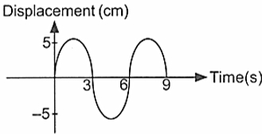  d) 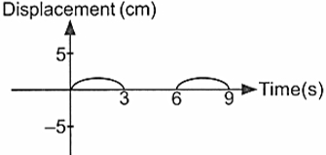 | [1]
26 | In the experiment of finding speed of a pulse propagated through a slinky, the pulse is produced.  a) by giving a jerk to slinky in a direction Perpendicular to its length.  b) by giving a jerk to slinky in vertically upward direction.  c) by pushing the slinky so as to compress it.  d) by pulling the slinky towards us. | [1]
27 | The distance between two consecutive compression of a sound wave is 5 cm. Then the wavelength of the wave is equal to  a) 2.5 cm  b) 20 cm  c) 10 cm  d) 5 cm | [1]
28 | Noise and Music differ in their  a) pitch  b) quality  c) note  d) tone | [1]
29 | Infrasonic soundis produced by:  a) Rhinoceros  b) Dogs  c) Rats  d) Bats | [1]
30 | In compression, the density of the particles:  a) Decreases  b) May be increasedordecrease depending upon disturbance  c) Remains the same  d) Increases | [1]
31 | A man who is standing at a point between two parallel walls fires a pistol. He hears echoes after 0.5 s and 0.8 s. A further echo is heard, after firing, at a time of ________.(Speed of sound = 330 m s $​^{−1}$ )  a) 1.1 s  b) 1.3 s  c) 2.6 s  d) 2.2 s | [1]
32 | The wave number of wave of wavelength 10 m is  a) 10m$​^{−1}$  b) 100m$​^{−1}$  c) 0.01m$​^{−1}$  d) 0.1 m$​^{−1}$ | [1]
33 | A bat can hear frequencies upto 120 kHz. Considering the speed of the sound to be 300 m/s, the wavelength of the signal is  a) 5 m  b) 1.25 m  c) 0.25 cm  d) 2.05 m | [1]
34 | The terms ultrasonic, supersonic and infrasonic mean  a) increasing frequency  b) different parameters and so cannot be related  c) increasing loudness  d) decreasing frequency | [1]
35 | An insect makes sound that is higher than the maximum audible frequency of human beings. Given that speed of sound in air is approximately 340 m s$​^{−1}$ , which of the following could be the wavelength of the sound?  a) 3.2$×$ 10 $​^{−1}$ m  b) 1.4$×$ 10 $​^{−2}$ m  c) 5.0 m  d) 3.6$×$ 10 $​^{−2}$ m | [1]
36 | A microphone is connected to a cathode ray oscilloscope. A loudspeaker giving a single note is switch on. The trace shown in the figure appears on the screen. 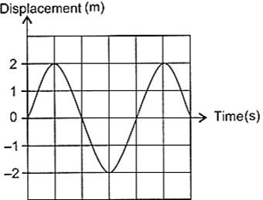  Which of the following shows the softer but same frequency note of the given note?  a) 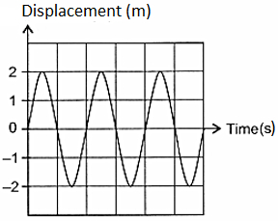  b) 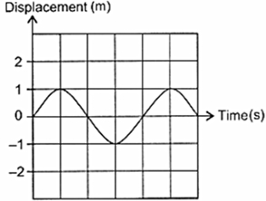  c) 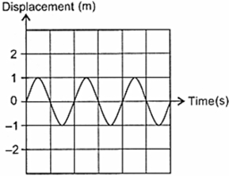  d) 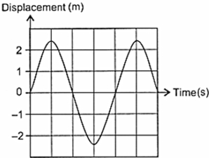 | [1]
37 | Sonic booms are caused due to the variation of  a) pressure  b) humidity  c) loudness  d) speed | [1]
38 | Absorbent materials are to be used while making interior design in an auditorium as  a) sound travels with a lesser velocity  b) reverberation time has to be decreased  c) it has to look good  d) echo is to be increased | [1]
39 | Earthquake produces which kind of sound before the main shock wave begins  a) Audible sound  b) Ultrasound  c) Infrasound  d) As a supersonic wave | [1]
40 | Stethoscope workson the principle of:  a) Refraction of sound  b) Multiple reflections of sound  c) Ultrasounds  d) Both multiple reflections of soundand ultrasound | [1]
41 | In air medium at room temperature speed of sound is 345 m/s. If a tuning fork produces a pure tone of 1 kHz the wavelength of sound produced in air is:  a) 3.45 m  b) 345 m  c) 34.5 m  d) 0.345 m | [1]
42 | The frequency of a source is 20 kHz. The frequencies of the sound waves produced by it in water and air will  a) Depend upon the wavelength of the waves in these media  b) Depend upon the velocity of the waves in these media  c) Be the same as that of the source  d) Depend upon the density of the media. | [1]
43 | In an experiment to determine the speed of sound, a gun was fired and an observer at a distance away measured the time interval between seeing the flash of the gun and hearing the shot. Which of the following will not affect the result?  - The frequency of the gunshot.  - The temperature of the environment.  - The loudness of the gunshot.  a) (i) and (ii) only  b) (i) and (iii) only  c) (ii) and (iii) only  d) (i), (ii) and(iii) | [1]
44 | The instruments Megaphone, Stethoscope, Hearing acids and Soundboards work based on the principle of:  a) reflection  b) absorption  c) persistence  d) reverberation | [1]
45 | Curved soundboard may be placed behind the stage because:  a) it reflects the sound to a particular point in the hall  b) it makes the stage look beautiful  c) sound waves may be absorbed  d) after reflection, sound waves spread evenly across the width of the hall. | [1]
46 | Shyamal was calculating the velocity of the wave using a slinky. He asked his teacher regarding the features of spring to be used. The teacher replied that the spring should be.  a) Long, soft and flexible  b) Short, hard and flexible  c) Short, soft and flexible  d) Long, soft but not flexible | [1]
47 | When sound gets reflected from a surface:  a) the angle of reflection is always less than the angle of incidence  b) the angle of reflection is always equal to the angle of incidence  c) the angle of reflection is always equal to 90$​^{o}$  d) the angle of reflection is always more than the angle of incidence | [1]
48 | The penetrating power of ultrasonic waves and other audible sounds are given as f$​_{1}$ and f $​_{2}$ respectively. Then  a) f$​_{1}$ > f $​_{2}$  b) f$​_{1}$ = 2f $​_{2}$  c) f$​_{1}$ < f $​_{2}$  d) f$​_{1}$ = f $​_{2}$ | [1]
49 | Sound is produced when  a) The prongs of the fork are vibrated  b) Stretched rubber band is plucked  c) Mechanical vibrations are produced  d) All of these | [1]
50 | Ramjeet, while verifying the laws of reflection of sound, measured the angled between the incident sound wave and reflected wound wave to be 130$​^{o}$ . The angle of incidence is:  a) 65$​^{o}$  b) 25$​^{o}$  c) 130$​^{o}$  d) data insufficient | [1]
51 | Statement 1: Echo is produced when sound is incident on hard and polished surface. Statement 2: Sound energy can be totally reflected by the objects with soft and loose texture.  a) Both statements 1 and 2 are true but statement 2 is not the correct explanation of statement 1.  b) Both statements 1 and 2 are true and statement 2 is the correct explanation of statement 1.  c) Both statements 1 and 2 are false.  d) Statement 1 is true but statement 2 is false. | [1]
52 | A wave is moving with a speed of 3000 m/s with reversal after every 0.01 second. The wavelength of the wave is  a) 6 m  b) 0.06 m  c) 30 m  d) 300 m | [1]
53 | In the experiment for determining the velocity of a pulse propagating along the length of string, we prefer a long thick cotton string:  a) because pulse cannot be formed in a thin short string  b) so that pulse may move through it easily  c) because cotton string is cheap and easily available  d) So that time taken by pulse to move from one end to string to other may be accurately determined. | [1]
54 | In the bell jar experiment, as air is removed  a) elasticity falls  b) intensity falls  c) speed of sound falls  d) both intensity falls and speed of sound falls | [1]
55 | On a hot summer day, speed of sound was recorded at Chennai and Delhi as v$​_{c}$ and v $​_{d}$ then  a) cannot be related  b) v$​_{c}$ = v $​_{d}$  c) v$​_{c}$ < v $​_{d}$  d) v$​_{c}$ > v $​_{d}$ | [1]
56 | Frequency of ultrasonic waveis:  a) Greater than 2 MHz  b) Greater than 20 Hz  c) Greater than 2 Hz  d) Greater than 20,000 Hz | [1]
57 | The wave having an amplitude of 5 cm and frequency f = 100 Hz can be best represented by  a) $^{$  b) 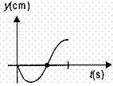  c) 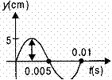  d) 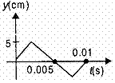 | [1]
58 | The minimum size of a room required to hear an echo of sound with a speed of 300 m/s is  a) 17 m  b) 15 m  c) 16 m  d) 14 m | [1]
59 | Reflection of sound obeys the law  a) $​​∠$ i = 2 $​​∠$ r  b) $​​∠$ i = $​​∠$ r  c) $​​∠$ i < $​​∠$ r  d) $​​∠$ i > $​​∠$ r | [1]
60 | Sound of crackers is heard during festival days, but the sound of supernova explosion in space is not heard on the surface of earth because of  a) lesser gravity  b) the influence of the other planets  c) large distance  d) absence of medium | [1]
61 | A stone is dropped from the top of a tower of 125 m high into a pond which is at base of the tower. When will the splash be heard at the top? (Given g = 10 m s$​^{−2}$ and speed of sound = 340 m s $​^{−1}$ .)  a) 5.36 s  b) 0.36 s  c) 5 s  d) 2 s | [1]
62 | Sound travels with a speed of about 330 m s$​^{−1}$ .What is the wavelength of sound whose frequency is 660 Hz?  a) 500 m  b) 5 m  c) 0.5  d) 50 m | [1]
63 | While verifying the laws of reflection of sound, out of following precautions which one should not be followed?  a) The reflecting surface should be smooth and hard  b) Ear should not be placed close to the pipe  c) The table top should be horizontal  d) Length of pipes should be sufficiently long | [1]
64 | A submarine emits a SONAR pulse which returns from an under water cliff in 1.05 second. If the speed of sound in salt water is 1531 m s$​^{−1}$ , how far away is the cliff?  a) 803.8 m  b) 1568 m  c) 765.5 m  d) 1607.4 m | [1]
65 | ________ have frequencies more than 20,000 hertz.  a) Different  b) Ultrasonics  c) Sound  d) Infrasonics | [1]
66 | The frequency of a visible light of wavelength 600 nm is (speed of light = 3 ×10$​^{8}$ m/s), (1nm = 10 $​^{−9}$ m)  a) 50 Hz  b) 5 × 10$​^{14}$ Hz  c) 0.5$×$ 10 $​^{16}$ Hz  d) 500 Hz | [1]
67 | The diagram represents two different sound waves. 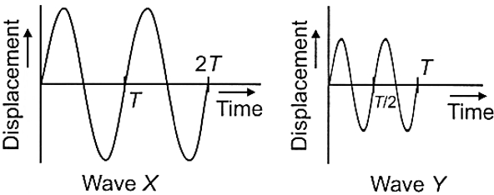  a) The frequency of is less than Y but its pitch is same as Y.  b) The frequency and pitch of X is same as the frequency and pitch of Y.  c) The frequency and pitch of X is less than that of Y of X is less than y.  d) The frequency of X is same as Y but its pitch is higher than Y. | [1]
68 | In the experiment of verification of reflection of sound, the incident sound is directed along:  a) axis of tube  b) at an angle of 45$​^{o}$ from the axis of the tube  c) normal to the axis of tube  d) at an angle of 30$​^{o}$ from the axis of the tube | [1]
69 | A sound wave travelling in a medium is represented as shown in figure. 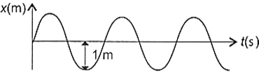  If vibrating source of sound makes 360 oscillations in 2 minutes, then the amplitude, wavelength ( $λ$ ) and frequency ( $ν$ ) of the sound wave respectively are (Take velocity of sound as 342 m s $​^{−1}$ )  a) 1 m, 100 m and 10 Hz  b) 2 m, 3 m and 14 Hz  c) 1 m, 114 m and 3 Hz  d) 1 m, 5 m and 20 Hz | [1]
70 | On which of the following factor the speed of propagation of pulse in a slinky does not depend?  a) Room temperature  b) Dimensions of slinky  c) Length of slinky  d) Material of slinky | [1]
71 | SI unitof frequency is:  a) (second)$​^{2}$  b) second  c) (second)$​^{−2}$  d) hertz | [1]
72 | Sound travels in air if  a) There is no moisture in the atmosphere  b) Both particles as well as disturbance travel from one place to another  c) Disturbance moves  d) Particles of medium travel from one place to another | [1]
73 | A student plotted the following four graphs representing the variation of velocity v of sound in a gas with the pressure P for a given temperature. Which one is correct?  a) 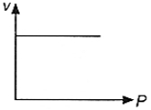  b) 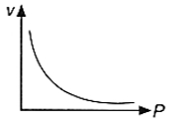  c) 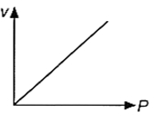  d) 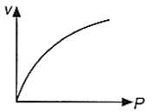 | [1]
74 | Note is sound  a) always unpleasant to listen  b) of mixture of several frequencies  c) of mixture of tow frequencies only  d) of a single frequency | [1]
75 | Which of the following is used in echocardiography?  a) X - Ray waves  b) Infrasound waves  c) Both Ultrasound waves and X - Ray waves  d) Ultrasound waves | [1]

